DAD 220 Module Five Major Activity

Overview

Review the scenario for this activity in the guidelines and rubric. Then complete the steps below as you work through the directions for this activity. Replace the bracketed text with your screenshots and responses to the prompts. Size each screenshot and its explanation to fit approximately one-quarter of the page with the description written below the screenshot. Review the Template Screenshot Example linked in the guidelines and rubric for this assignment to see an example of how screenshots for your assignment should look.

Create a Database

- Write SQL commands that capture specific, usable data that can be used in your analysis.

- Analyze the results of queries to identify specific information that can be presented in your summary.
  - Sales by region:
    - Analyze sales data by state to determine where the company has the largest customer base.

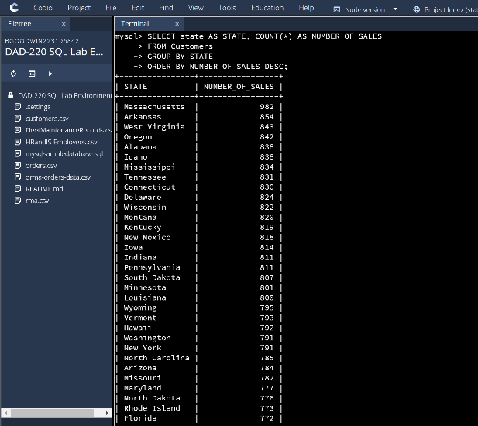
Given the data the largest customer base we have would be in Massachusetts’s and this was achieved by grouping states with the number of sales in each state.

    - Analyze the data to determine the top three products sold in the United States.

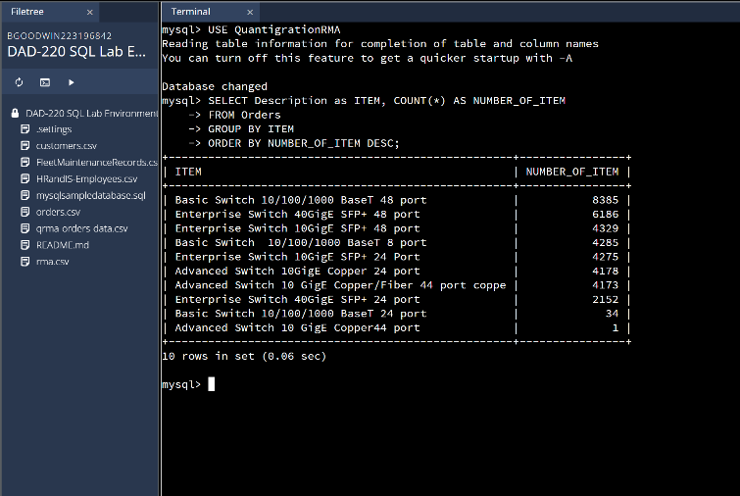
Given the data the 3 most items sold are Basic Switch 10/100/1000 BaseT 48 port, Enterprise Switch 40GigE SFP+ 48 port and Enterprise Switch 10GigE SFP+ 48 port.
    - Analyze the data to determine the top three products sold in the southeastern region of the United States.
- Southeastern states to include in your analysis: Virginia, North Carolina, South Carolina, and Georgia

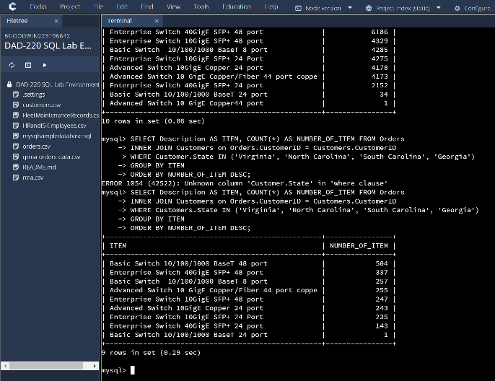
Given the Data the top 3 items sold in the southeastern states are Basic Switch 10/100/1000 BaseT 48 port, Enterprise Switch 40GigE SFP+ 48 port, and Basic Switch 10/100/1000 BaseT 8 port.
  - Returns by region:
    - Analyze the data to determine the top three products returned in the United States.

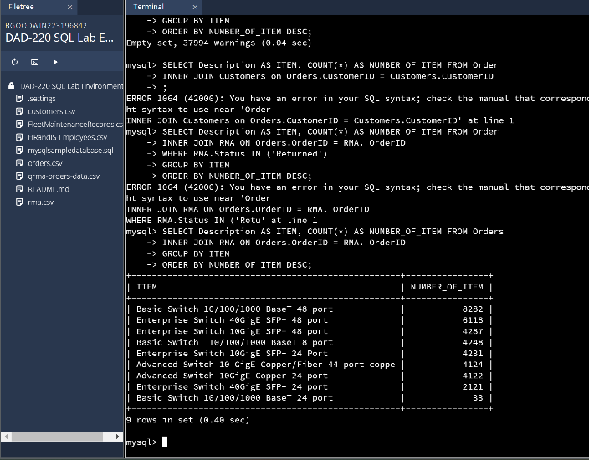
The top 3 returned products are Basic Switch 10/100/1000 BaseT 48 port, Enterprise Switch 40GigE SFP+ 48 port, and Enterprise Switch 10GigE SFP+ 48 port.
    - Analyze the data to determine the top three products returned in the northwestern region of the United States.
- Northwestern states to include in your analysis: Washington, Oregon, Idaho, and Montana
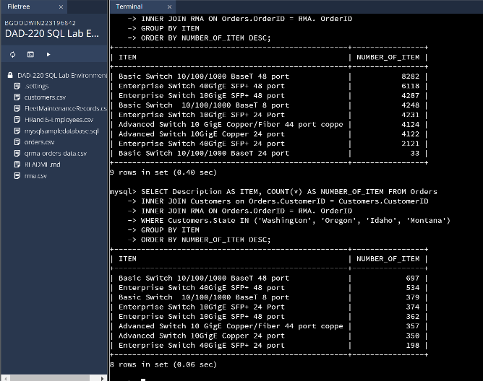

Given the Data the top 3 items returned in the Northwestern states are Basic Switch 10/100/1000 BaseT 48 port, Enterprise Switch 40GigE SFP+ 48 port, and Basic Switch 10/100/1000 BaseT 8 port.

- Write a report to the Quantigration product manager that explains your findings in a way nontechnical stakeholders can understand and use.
  - Provide an effective summary of your findings from the analysis of the sales and returns data you captured. Write at least one paragraph for each of your responses to the prompts below.

    - Sales data by region: Provide a well-written summary of findings from your analysis in Step Two, Part A.

With this information we can see which states have the most sales, which products sell the most, and what the most products sell per region of the US (In this case from the southeastern). The largest customer base we have would be in Massachusetts’s which has the most products sold in the country. The top items sold in the company are are Basic Switch 10/100/1000 BaseT 48 port, Enterprise Switch 40GigE SFP+ 48 port and Enterprise Switch 10GigE SFP+ 48 port. Finally, the most products sold in the southeastern region are Basic Switch 10/100/1000 BaseT 48 port, Enterprise Switch 40GigE SFP+ 48 port, and Basic Switch 10/100/1000 BaseT 8 port. With this information we can predict how many parts need to be made along with which regions or states will need the appropriate products.

    - Returns data by region: Provide a well-written summary of findings from your analysis in Step Two, Part B.

We looked up the data for returns in this next section focusing specifically on what the most returns were in the United States and where the most returns were in the Northwest region of the US. With our database and the information provided to it, we were able to find that the top three most returned products in the US were Basic Switch 10/100/1000 BaseT 48 port, Enterprise Switch 40GigE SFP+ 48 port, and Enterprise Switch 10GigE SFP+ 48 port. The most returns for the region of the Northwestern United States were Basic Switch 10/100/1000 BaseT 48 port, Enterprise Switch 40GigE SFP+ 48 port, and Basic Switch 10/100/1000 BaseT 8 port. We can use this to trouble shoot potential problems for the returns so that we can correct any errors on our part and hopefully have less returns over all.

